Instructor: John Beswetherick
Course: BUSIT 202
From: Christopher Singleton
Subject: Assignment7 – Dimensional Models for Education
Date: 02/23/2016

MEMO
This assignment had to do primarily with coming up with a multi-dimensional design that allows the Bellevue College faculty to do queries and analyze the registration data by course, quarter, time of day offered (day or evening courses) with a specified format.
In doing this assignment I also created a fact table simulated design for the Bellevue College Educational Institution at the lowest possible grain. The structure in the fact table includes the [Student Key] for connecting to the [Dim Student] table and the [Class Key] for connecting to the [Dim Class] table. The tables inter-connecting to the [Fact Student Course] ([Dim Date], [Dim Student], [Dim Faculty] and [Dim Class]) tables have what is included as the most likely attributes according to how you could slice and dice using an ad-hoc query and meets the criteria. I recommend to add an outrigger table for the demographics of the student (this is typical) and did so in my design in order to show how you can minimize the amount of attributes in the [Dim Student] table. Please note, that with an outrigger table, these are items that seldom change, utilize a snowflake schema, help speed up querying the main attributes and also help to keep from expanding the [Dim Student] table even more, which would slow down the database system even more. The draw-back of the outrigger table is that you would need to have longer queries (sacrifice in getting one for the other).

STUDENT REGISTRATION TABLE DESIGN
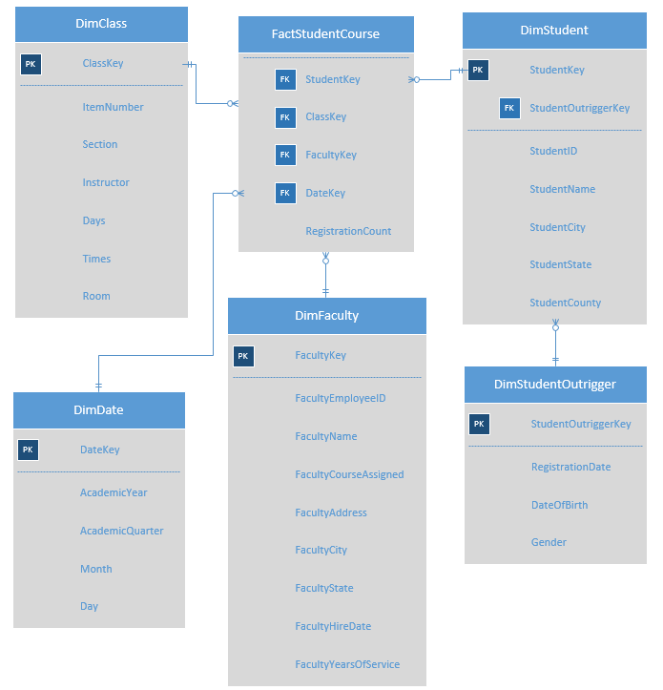

I put together this design because this table allows you to slice and dice with getting all the specified required information that is needed with day to day operations. The requirements mentioned to analyze registration data by course, which would use the [Fact Student Course] table, by faculty using the [Dim Faculty] table, by quarter using the [Dim Date] table and by time of day offered (online, day or evening classes) using the [Dim Class] table. The tables I just mentioned and in the above diagram all relate directly with querying and allow you to get all the information needed based on the criteria. The [Fact Student Course] table allows you to get the registration count utilizing the registration count measure attribute (another requirement); this tells you how many students registered, while the [Dim Student Outrigger] table gives you the registration date of the student. I think having a fact table is a better choice than having a fact-less fact table, because having the measurement in the fact table meets part of the specified criteria for querying the ad-hoc queries that are needed.

In the design above, I also decided to go with an outrigger bridge table as part of my design in order to reduce the amount of information in the fact table. This also allows for expandability with more attributes in the future and increases the efficiency of the fact table. The major draw-back of having an outrigger table in the design is that you have longer queries in getting unchanging student attributes, but in the compromise you have the ability to increase the attributes with more student demographics in the outrigger table. Although, there are more attributes that can be added in the future, I put the attributes of what I thought was necessary in getting the required information. I specifically tailored the [Dim Class] table according to the Bellevue College website, because in thinking this is how they currently have it and would not want any other changes unless it’s necessary with their instructions. I think it is most important to elaborate in getting as much information as possible with what and how they want in getting their information. The rest of the tables have nearly everything that I could think of in being able to get the required data. The key information is having to do with the students and faculty (dates and times allocated).

Extra Credit (3 pts) Accumulated Snap-Shot
The accumulating snapshot is all about measurement of events at steps throughout a process. The fact table row is revisited throughout the process and continually updated, which allows for easy analysis. In the accumulating snapshot you define a begin point, intermediate points for steps along the way and a process completion point. Definitely, the accumulating snapshot is the way to go if your trying to get information on what events did not complete fully, in otherwords who did not complete their course, who completed their course, as well in results with who scored lowest on the tests at certain levels, academic grade levels, products that did not complete in the making or were discarded because of flaws along the process in building a complete module, unit or sub unit. Accumulating snapshot is perfect with analysis for identifying where problems exist with processes and where changes need to take place based on the data accumulated.

The measures that would exist in the accumulating snap-shot for those students who completed or did not complete their course would be [Number Of Classes Taken], [Number Of Classes Passed], [Number Of Classes Failed]. Each part is considered a snap-shot through-out the duration process captured in steps. In other words, if the student failed zero classes, he passed the process completely in completing their goals. Accumulating snap-shots can be taken at each step of the process. Take for instance in applying for a certificate, you are measured two months in advanced to see if you can be granted in getting your certificate. If you don’t meet the criteria or window that is measured, then they won’t allow you to get your certificate, otherwise they will grant you the certificate. I’m sure each student can be measured on whether or not a student is granted a certificate based on an accumulating snap-shot.

Hi Chris, You did a good job on the assignment, there are a few areas you can expand on, including reports and factless fact tables. Attached is an example, could you update your assignment with a little more info so I can give you full credit? Thanks, John

